Eg: String_Eg76
Whenever the + operator is used and at least one operand is a String, Java performs string concatenation by internally calling String.valueOf() on both operands.
String.valueOf() safely converts null into the string "null", so no NullPointerException is thrown.

Eg: String_Eg77
// go through the code

Eg: String_Eg78
Effect of overriding toString()
Class | Overrides toString()? | Output
String | ✅ Yes | content
StringBuilder | ✅ Yes | content
Special_String | ❌ No | class@hash
null | — | "null"

🧠 One-Line Interview Takeaway
System.out.println(object) calls toString() at runtime, and the output depends on whether the class overrides toString().

Eg: String_Eg79
// go through the code

Eg: String_Eg80
// go through the code.

Eg: String_Eg81
// go through the code.

Eg: String_Eg82
// go through the code.

Eg: String_Eg83
// go through the code.

Eg: String_Eg84
1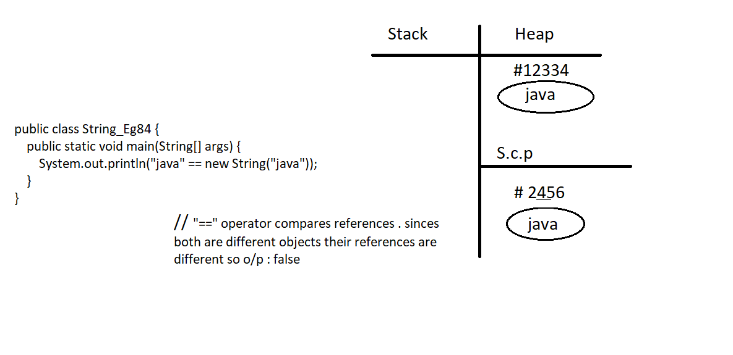

Eg: String_Eg85
Difference between strip() and trim() in Java
Feature | trim() | strip()
Java version | Available from Java 1.0 | Available from Java 11
Removes spaces from | Beginning and end only | Beginning and end only
Unicode support | ❌ No | ✅ Yes
Removes tab (\t) | ❌ No | ✅ Yes
Removes newline (\n) | ❌ No | ✅ Yes
Modern usage | Old method | Recommended method

1️⃣ trim()
- Removes only ASCII space characters (character value ≤ 32)
- Does not remove Unicode spaces
- Older method
Example:
String s = " \t Hello \n ";
System.out.println(s.trim());
➡ Output may still contain tab or newline

2️⃣ strip()
- Removes all Unicode white spaces
- Handles spaces, tabs, new lines properly
- Modern and better than trim()
Example:
String s = " \t Hello \n ";
System.out.println(s.strip());
➡ Output: Hello

⭐ Interview one-line answer
strip() is Unicode-aware and available from Java 11, while trim() removes only basic ASCII spaces and is an older method.

Eg: String_Eg86
🔹 Step 1: String literals loaded (String Constant Pool – SCP)
When the program starts, all string literals are placed in the String Constant Pool.
String Constant Pool (SCP)
--------------------------------
"string" → reference A
"STRING" → reference B
- "string" and "STRING" are different objects
- Case difference → different memory locations

🔹 Step 2: Execution of "string".toUpperCase()
"string".toUpperCase()
- "string" is already in SCP
- toUpperCase() creates a NEW String object
- Result value = "STRING"
⚠️ Important:
- toUpperCase() does NOT reuse SCP automatically
- It creates a new object in Heap memory
Heap Memory
--------------------------------
new String("STRING") → reference C

🔹 Step 3: Memory state before comparison
String Constant Pool (SCP)
--------------------------------
"string" → A
"STRING" → B

Heap Memory
--------------------------------
"STRING" (from toUpperCase) → C

🔹 Step 4: == comparison
"string".toUpperCase() == "STRING"
What == checks:
👉 Memory reference, not content
Comparison happening:
C == B
- Reference C (Heap) ❌
- Reference B (SCP) ❌
- Different memory locations
➡ Result = false

🔹 Step 5: Output
false
So this line executes:
System.out.println(false);

🔹 Final Memory Map (Complete View)
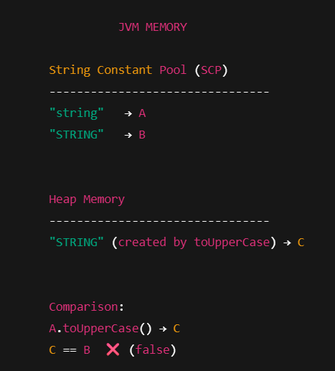

Eg: String_Eg87
// go through the code.

Eg: String_Eg88
//go through the code.

Eg: String_Eg89
// go through the code

Eg: String_Eg90
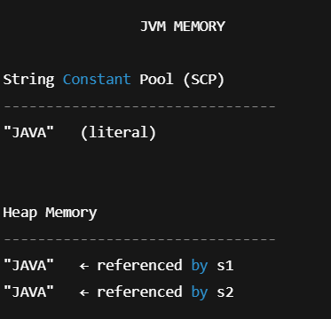

Eg: String_Eg91
// go through the code.

Eg: String_Eg92
// go through the code

Eg: String_Eg93
// go through the code.

Eg: String_Eg94
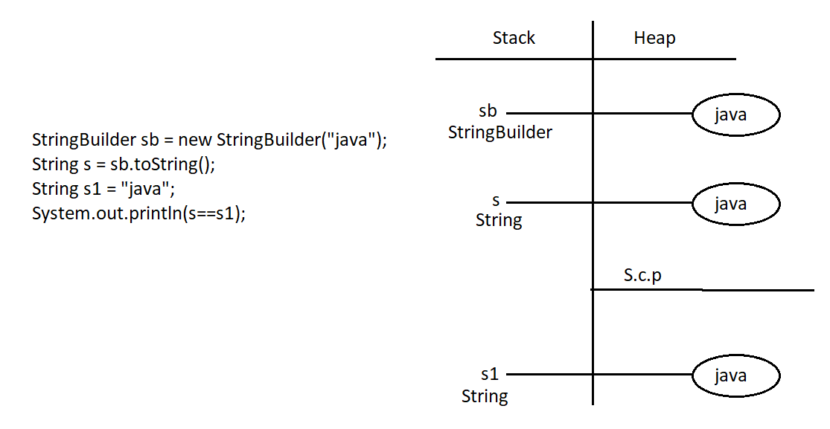

Eg: String_Eg95
“If operation is done on the same string object and the result is the same, the reference would point to the original object. But since it is StringBuilder, that rule is not applied.”

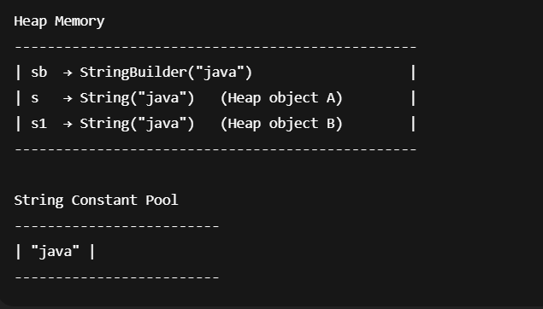

Eg:String_Eg96
// go through the code

Eg: String_Eg97
🔴 Actual Problem 1: new StringBuilder(null)
What compiler does
- Compiler sees only one matching constructor:
- StringBuilder(String str)
- null can be assigned to String → ✔ compile-time OK
What happens at runtime
- JVM tries to copy characters from null
- ❌ NullPointerException
✅ So this line causes runtime error, NOT compile-time error.

🔴 Actual Problem 2: sb.append(null) (Overloading confusion)
If we write this code separately:
StringBuilder sb = new StringBuilder("java");
sb.append(null);
Why this causes compile-time error
StringBuilder has overloaded append methods:
append(String str)
append(StringBuffer sb)
Now compiler sees:
append(null)
Compiler confusion 🤯
- null can belong to:
  - String
  - StringBuffer
- Both methods are equally valid
- Compiler cannot decide which method to call
❌ Result: Compile-time error (Ambiguous method call)

📌 Important Correction to Your Comment
❌ Your comment said:
compiler doesn't understand where to store null either in String or StringBuffer
✅ Correct version:
compiler doesn't know which overloaded append method to invoke because null matches both String and StringBuffer

🧠 Summary Table
Code | Error Type | Reason
new StringBuilder(null) | Runtime error | NullPointerException
sb.append(null) | Compile-time error | Ambiguous overloaded method

⭐ Interview One-Liner (Very Important)
null causes ambiguity only in method overloading, not constructor selection (when only one match exists).

